Санкт-Петербургский Национальный Исследовательский  
Университет ИТМО

Факультет программной инженерии и компьютерной техники

**Домашняя работа №1**

По дискретной математике

Вариант 76

Выполнил:

Студент группы P3117

Васильченко Роман Антонович

Преподаватель:

Поляков Владимир Иванович



Санкт-Петербург

2021

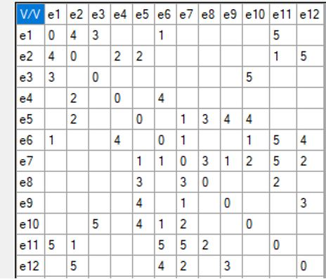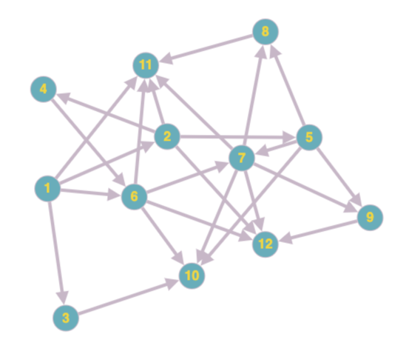

|  |  |  |  |  |  |  |  |  |  |  |  |  |  |
| --- | --- | --- | --- | --- | --- | --- | --- | --- | --- | --- | --- | --- | --- |
|  | X1 | X2 | X3 | X4 | X5 | X6 | X7 | X8 | X9 | X10 | X11 | X12 | ri |
| X1 | 0 | 1 | 1 |  |  | 1 |  |  |  |  | 1 |  | 4 |
| X2 | 1 | 0 |  | 1 | 1 |  |  |  |  |  | 1 | 1 | 5 |
| X3 | 1 |  | 0 |  |  |  |  |  |  | 1 |  |  | 2 |
| X4 |  | 1 |  | 0 |  | 1 |  |  |  |  |  |  | 2 |
| X5 |  | 1 |  |  | 0 |  | 1 | 1 | 1 | 1 |  |  | 5 |
| X6 | 1 |  |  | 1 |  | 0 | 1 |  |  | 1 | 1 | 1 | 6 |
| X7 |  |  |  |  | 1 | 1 | 0 | 1 | 1 | 1 | 1 | 1 | 7 |
| X8 |  |  |  |  | 1 |  | 1 | 0 |  |  | 1 |  | 3 |
| X9 |  |  |  |  | 1 |  | 1 |  | 0 |  |  | 1 | 3 |
| X10 |  |  | 1 |  | 1 | 1 | 1 |  |  | 0 |  |  | 4 |
| X11 | 1 | 1 |  |  |  | 1 | 1 | 1 |  |  | 0 |  | 5 |
| X12 |  | 1 |  |  |  | 1 | 1 |  | 1 |  |  | 0 | 4 |

Стартовое значение j = 1;

Сортировка по не возрастания:

X7, X6, X2, X5, X11, X1,X10, X12, X8, X9, X3, X4

X7, X2, X3 – красим данные вершины цветом (1)

Удаляем эти вершины

j = j+1 = 2

|  |  |  |  |  |  |  |  |  |  |  |
| --- | --- | --- | --- | --- | --- | --- | --- | --- | --- | --- |
|  | X1 | X4 | X5 | X6 | X8 | X9 | X10 | X11 | X12 | ri |
| X1 | 0 |  |  | 1 |  |  |  | 1 |  | 2 |
| X4 |  | 0 |  | 1 |  |  |  |  |  | 1 |
| X5 |  |  | 0 |  | 1 | 1 | 1 |  |  | 3 |
| X6 | 1 | 1 |  | 0 |  |  | 1 | 1 | 1 | 5 |
| X8 |  |  | 1 |  | 0 |  |  | 1 |  | 2 |
| X9 |  |  | 1 |  |  | 0 |  |  | 1 | 2 |
| X10 |  |  | 1 | 1 |  |  | 0 |  |  | 2 |
| X11 | 1 |  |  | 1 | 1 |  |  | 0 |  | 3 |
| X12 |  |  |  | 1 |  | 1 |  |  | 0 | 2 |

Сортировка по не возрастания:

X6, X5, X11, X1, X8, X9, X10, X12, X4

X6, X8, X9 – красим данные вершины цветом (2)

Удаляем эти вершины

j = j+1 = 3

|  |  |  |  |  |  |  |  |
| --- | --- | --- | --- | --- | --- | --- | --- |
|  | X1 | X4 | X5 | X10 | X11 | X12 | ri |
| X1 | 0 |  |  |  | 1 |  | 1 |
| X4 |  | 0 |  |  |  |  | 0 |
| X5 |  |  | 0 | 1 |  |  | 1 |
| X10 |  |  | 1 | 0 |  |  | 1 |
| X11 | 1 |  |  |  | 0 |  | 1 |
| X12 |  |  |  |  |  | 0 | 0 |

Сортировка по не возрастания:

X1, X5 – красим данные вершины цветом (3)

Удаляем эти вершины

|  |  |  |  |  |  |
| --- | --- | --- | --- | --- | --- |
|  | X4 | X10 | X11 | X12 | ri |
| X4 | 0 |  |  |  | 0 |
| X10 |  | 0 |  |  | 0 |
| X11 |  |  | 0 |  | 0 |
| X12 |  |  |  | 0 | 0 |

Остальные вершины красим цветом (4)